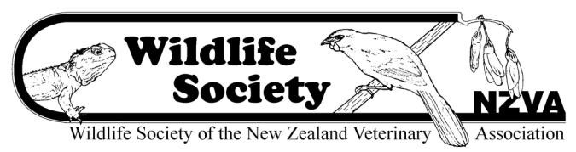

NZVA WILDLIFE SOCIETY PRACTITIONERS GRANT Criteria and Application Form
Applications open on 1st September 2020 and close on 31st October 2020. Applications must be received by midnight on 31st October 2020 to be considered.
(Applications to be typed)

The Wildlife Society Practitioners Grant was established in 2013 to provide support to veterinarians in practice who have a strong interest in further developing their veterinary skills for working with native New Zealand wildlife species.

The grant may be used for funding continuing education in this field, either through online courses &/or practical placements at wildlife veterinary centres, or for practice-based wildlife disease investigation &/or diagnostics.

Our purpose for such a fund is to increase the skills and knowledge of general practice veterinarians in wildlife medicine and surgery and to promote the benefits of treating wildlife in practice.

There is a maximum allocation of $2000 per annum. This is usually awarded to a single applicant, although The Society can divide the grant money in the case of two or more outstanding applicants. The successful applicant is expected to provide a short report on their use of the fund and will be encouraged to share any outcomes that may be beneficial to other veterinarians with an interest in wildlife. The grant must be used within one year of being awarded, unless otherwise arranged with the committee.

Name:
Address:
Email:
Phone:
Practice:

In 600 words or less give a brief summary of your veterinary career to date, why you have an interest in up-skilling in wildlife health, and if successful in receiving this grant how you would use the funds. Please include a budget.

Send applications to: Wildlife@vets.org.nz with ‘2020 Practitioners Grant application’ in subject line.

